**Create Moodle in AWS**

**Step 1:**

* Open AWS console
* Search for EC2
* Go for Instances
* Click on Launch Instance

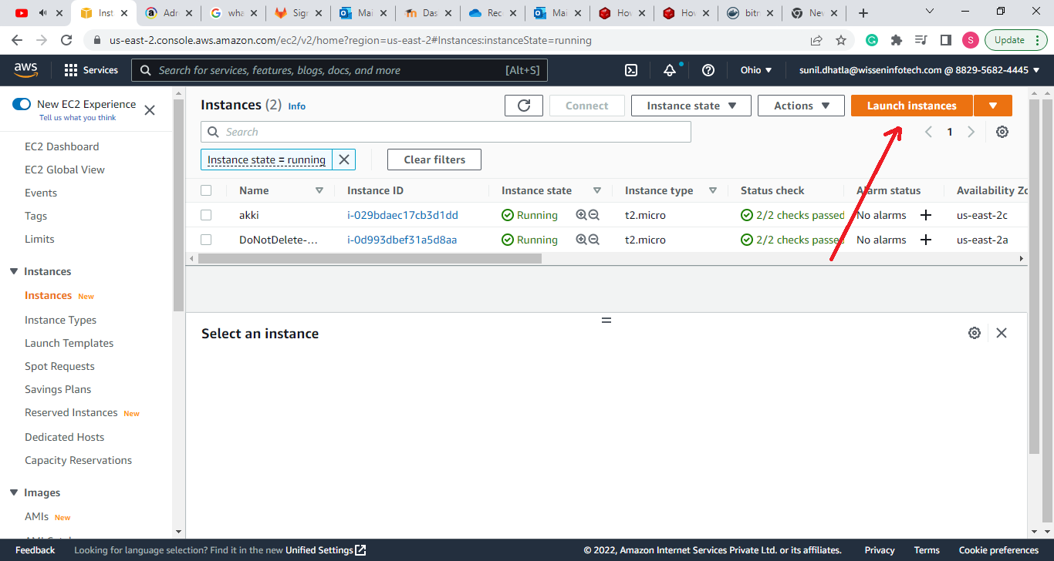

- Create the Instance

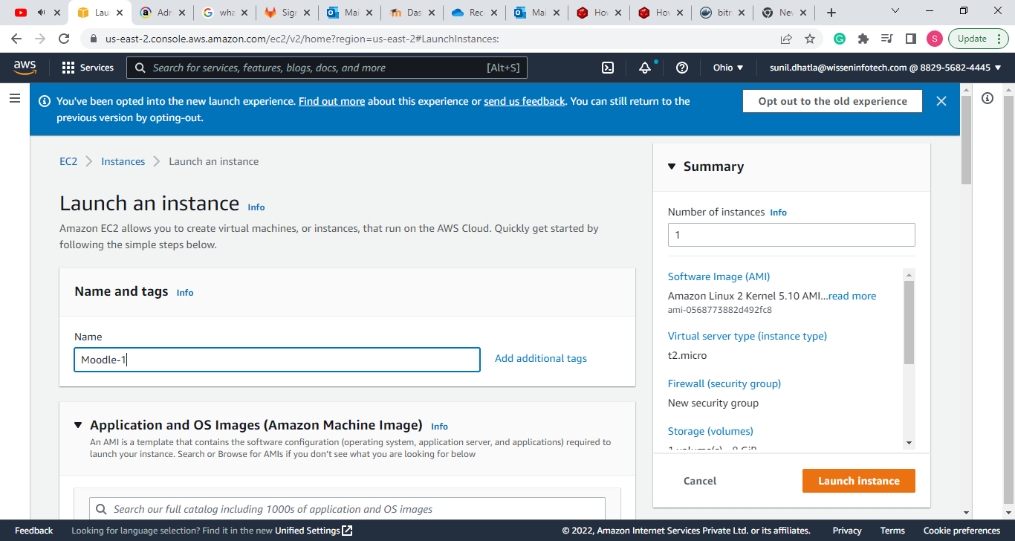

* Select AMI (as per your Convenience)

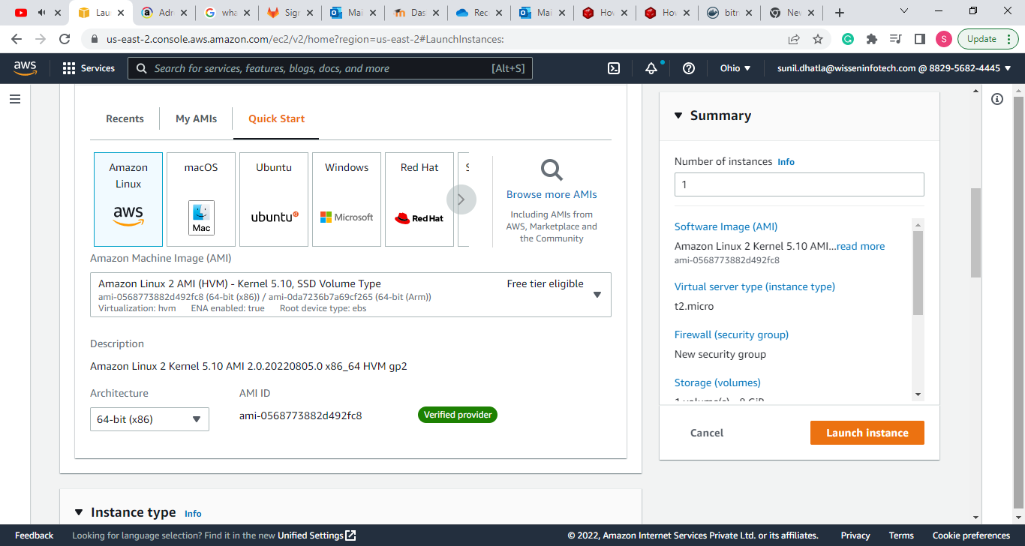

* Select Instance Type (Free tier or as per your convenience)

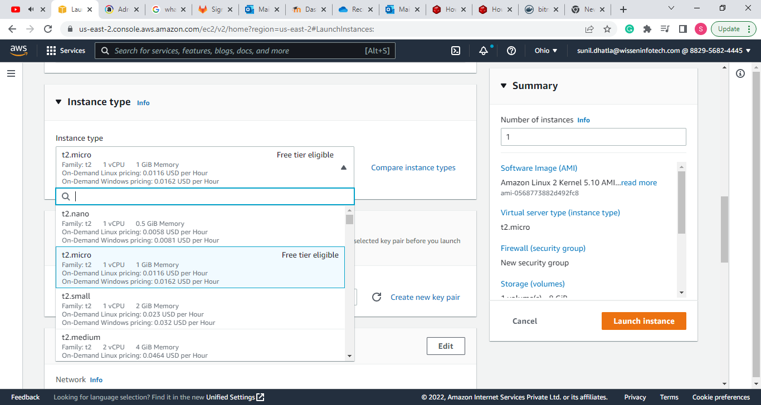

* Create New Key Pair or use Existing one

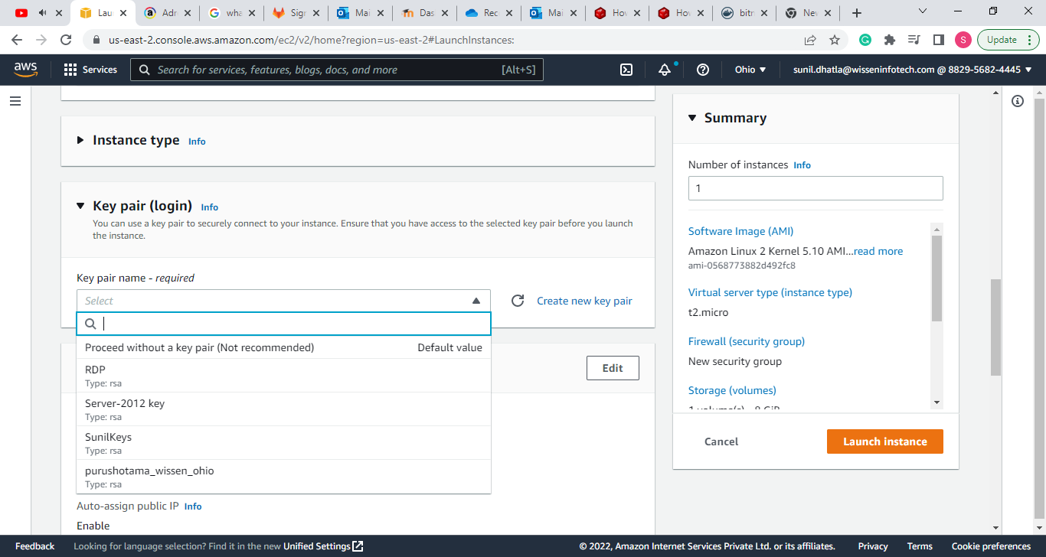

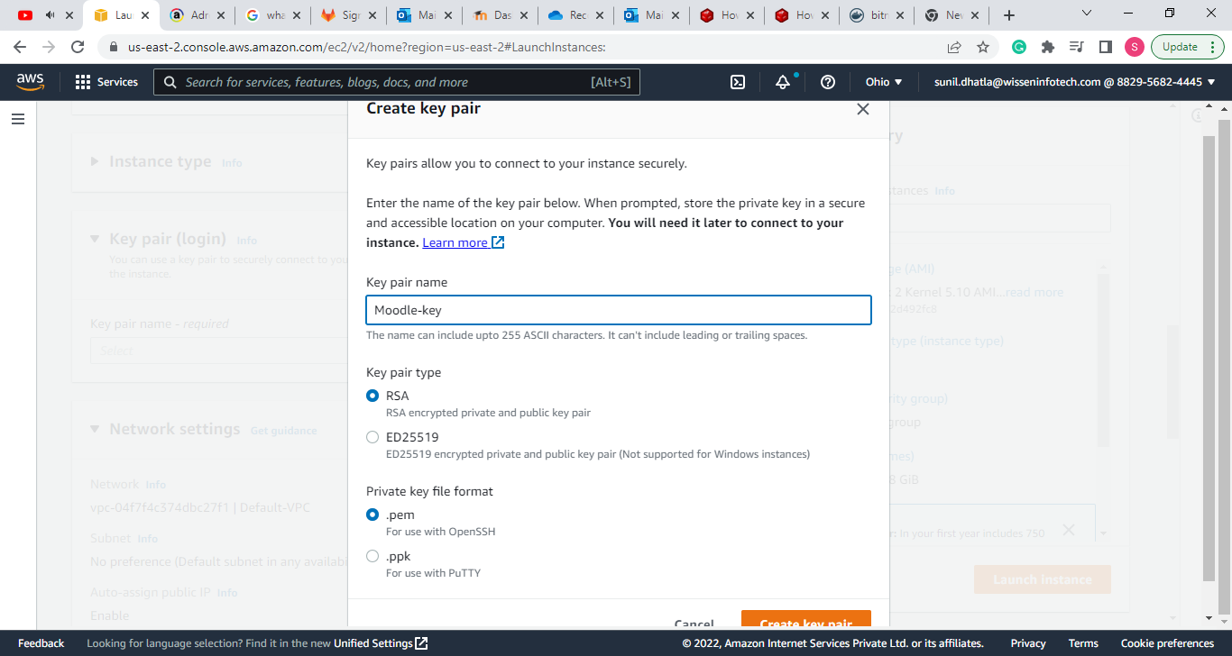

* Select Network Setting

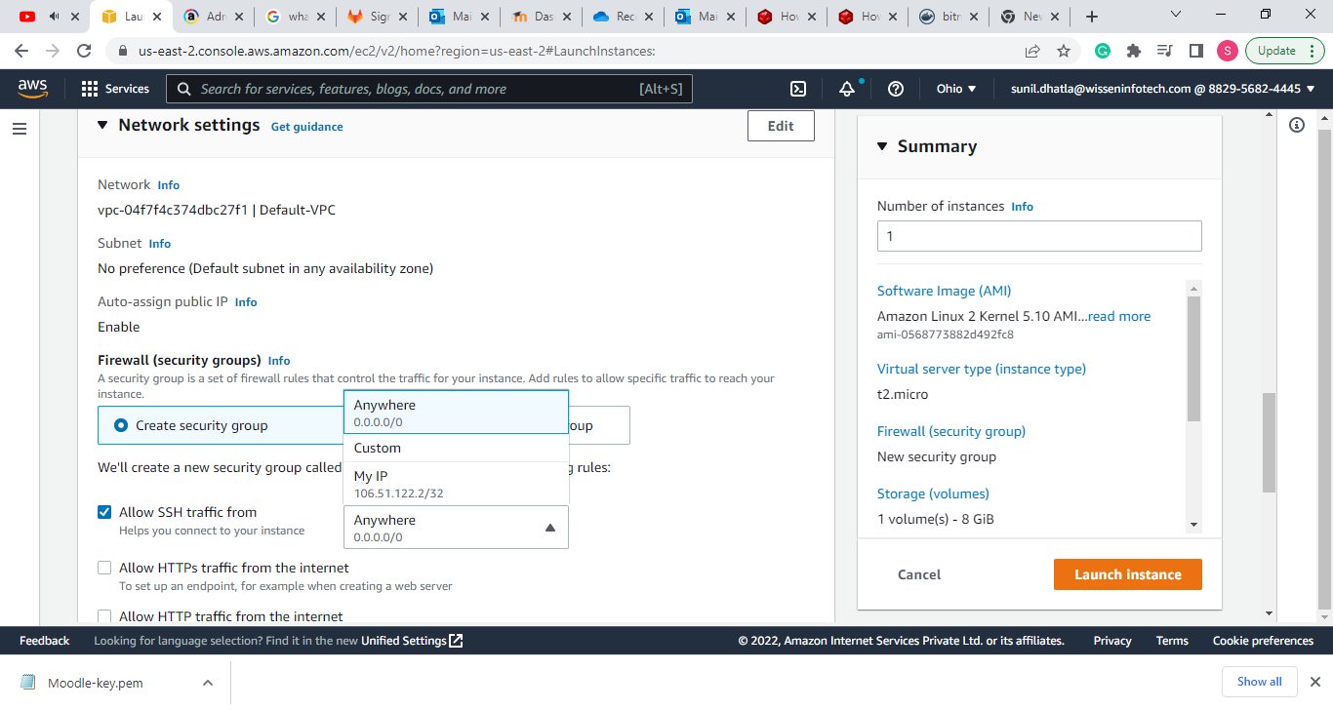

* Configure the Storage

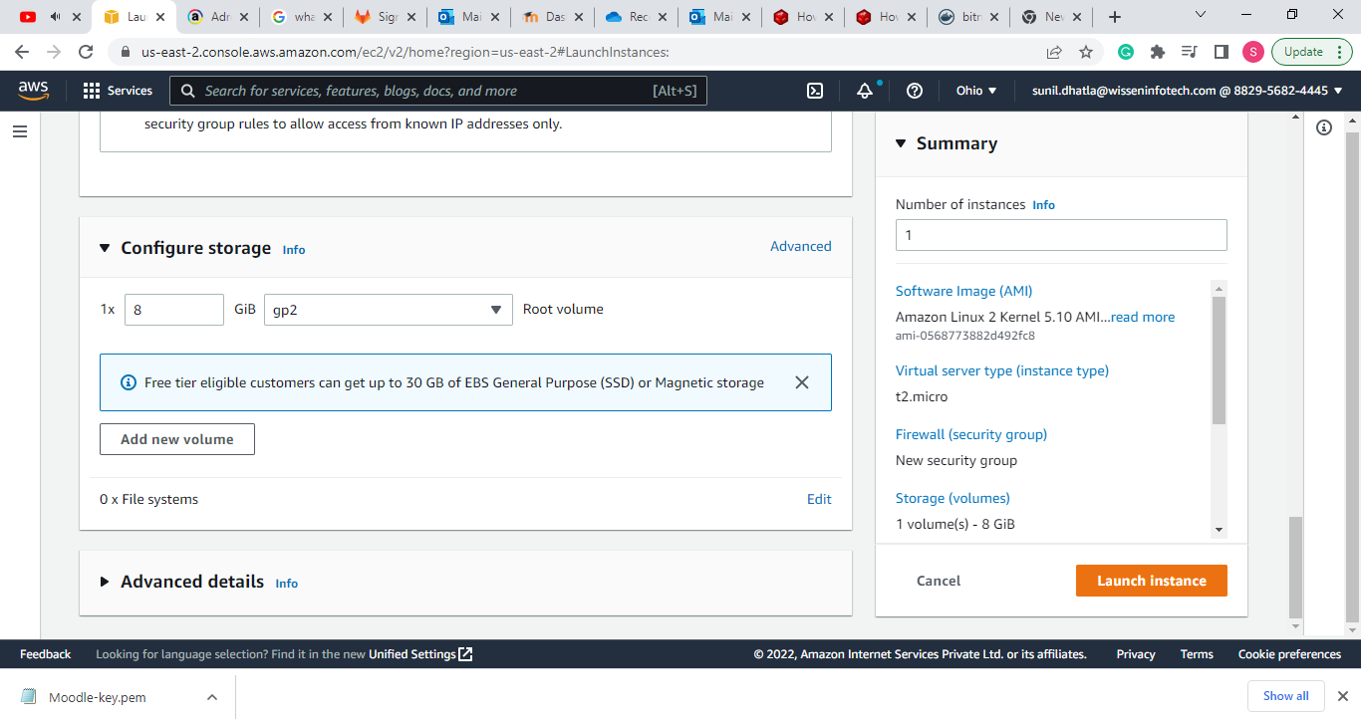

* Finally Launch the instance

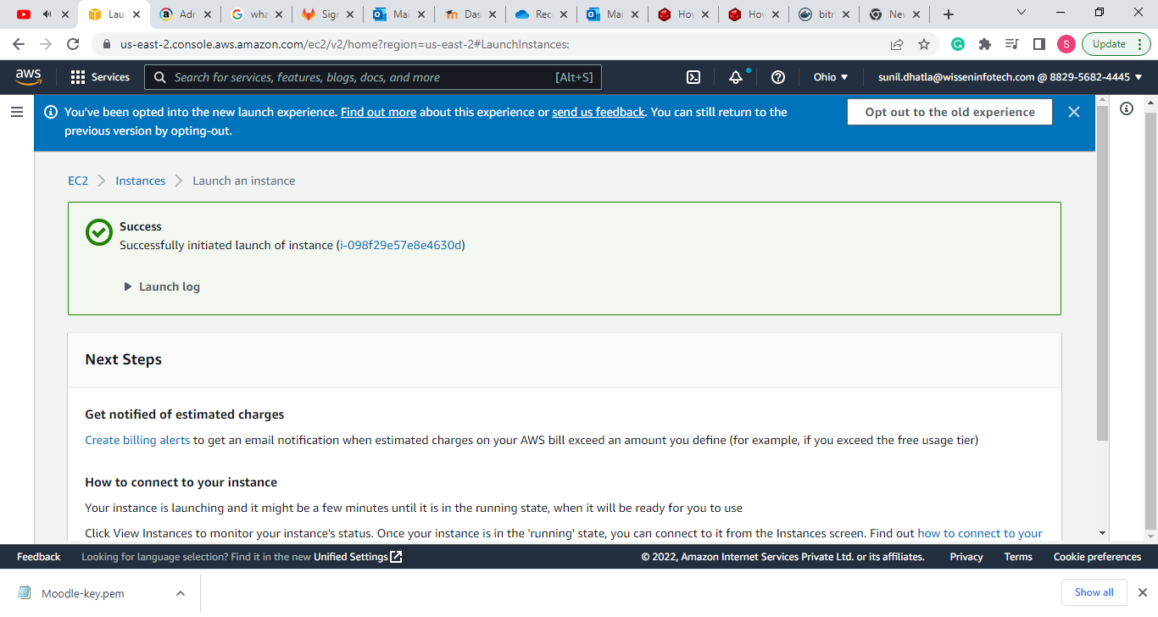

**Step 2: After creating the instance select the created instance and connect with Linux.**

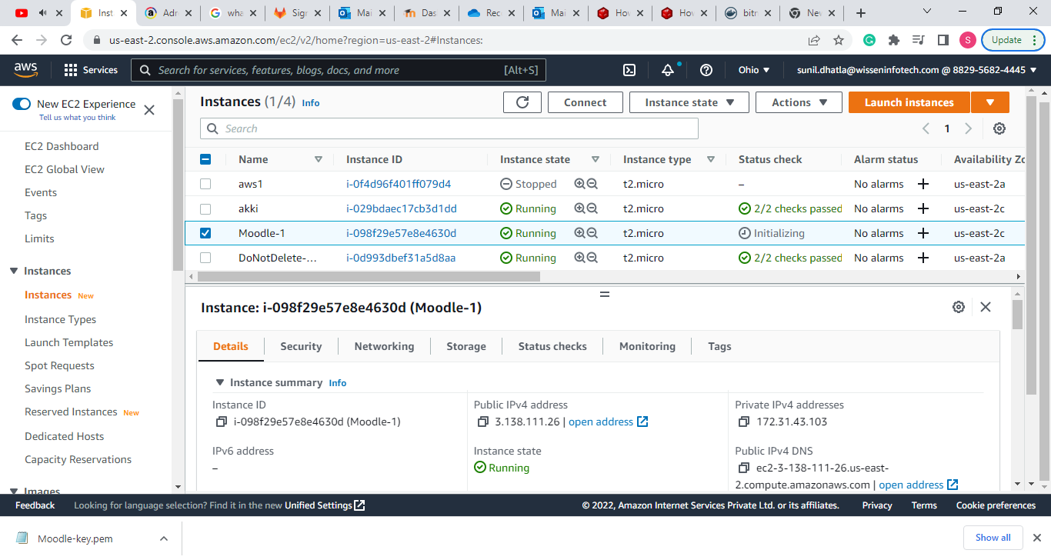

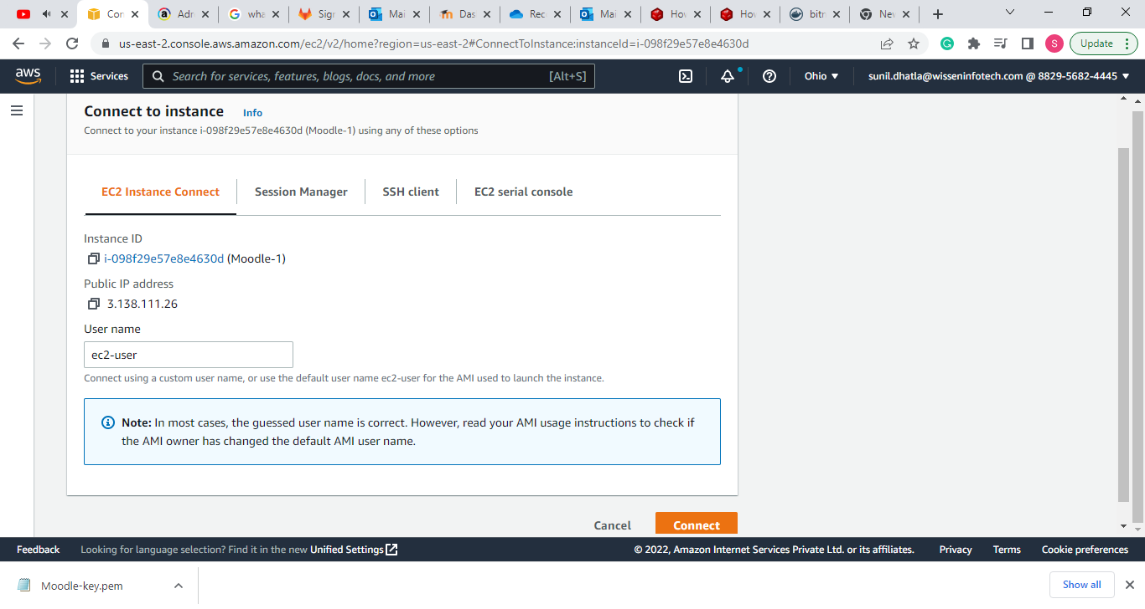

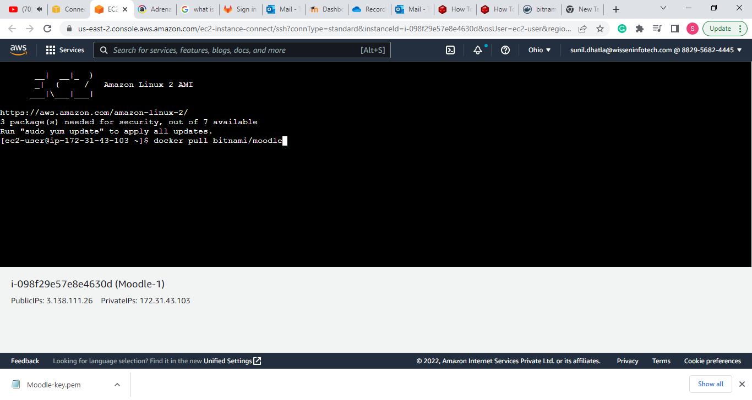

**Step 3: Now install the docker in the VM**

1. sudo yum update –y
2. sudo yum install docker –y
3. sudo service docker start

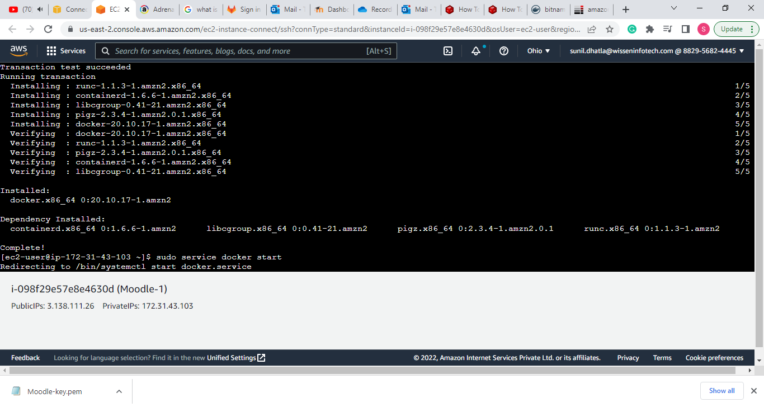

**Next check the docker status**

* Systemctl status docker

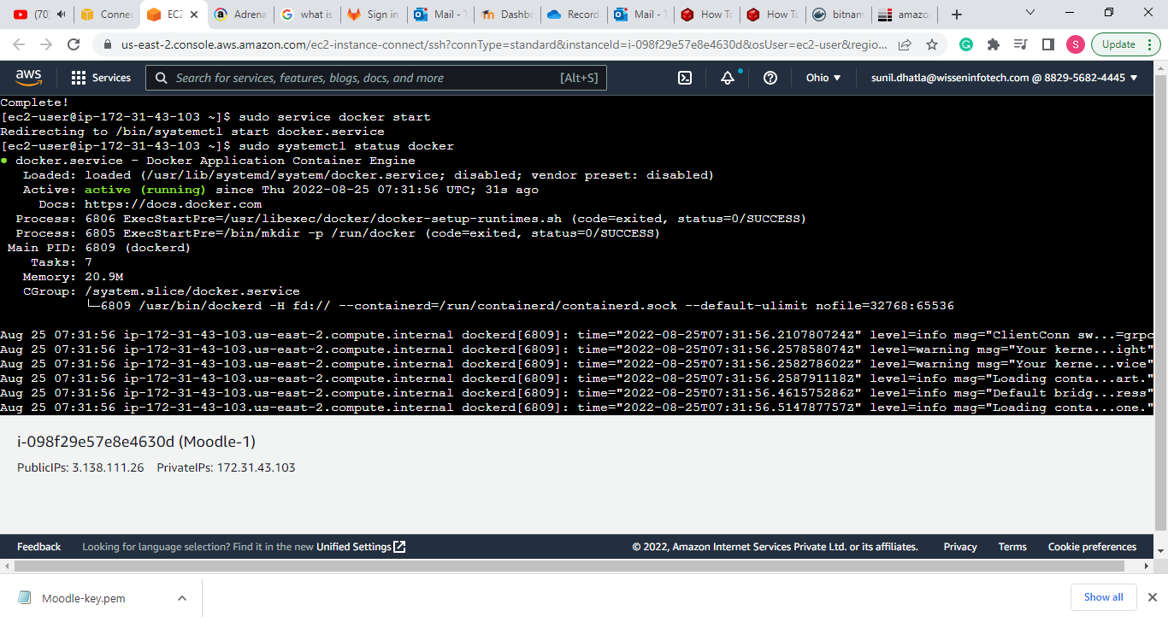

**Step 4: Install Docker Compose**

* sudo curl -L https://github.com/docker/compose/releases/download/1.21.0/docker-compose-`uname -s`-`uname -m` | sudo tee /usr/local/bin/docker-compose > /dev/null
* sudo chmod +x /usr/local/bin/docker-compose
* ln -s /usr/local/bin/docker-compose /usr/bin/docker-compose
* docker-compose --version

**Step 5: Pull the Bitnami/Moodle image**

* docker pull bitnami/moodle

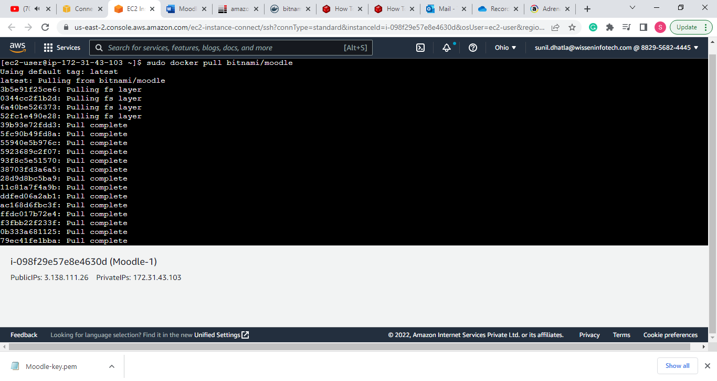

**Create a Network**

* docker volume create --name mariadb_data

**Create Volume for MariaDB**

* docker run -d --name mariadb \  
   --env ALLOW_EMPTY_PASSWORD=yes \  
   --env MARIADB_USER=bn_moodle \  
   --env MARIADB_PASSWORD=bitnami \  
   --env MARIADB_DATABASE=bitnami_moodle \  
   --network moodle-network \  
   --volume mariadb_data:/bitnami/mariadb \  
   bitnami/mariadb:latest

**Create Volume for Moodle**

* docker volume create --name moodle_data
* docker run -d --name moodle \  
   -p 8080:8080 -p 8443:8443 \  
   --env ALLOW_EMPTY_PASSWORD=yes \  
   --env MOODLE_DATABASE_USER=bn_moodle \  
   --env MOODLE_DATABASE_PASSWORD=bitnami \  
   --env MOODLE_DATABASE_NAME=bitnami_moodle \  
   --network moodle-network \  
   --volume moodle_data:/bitnami/moodle \  
   bitnami/moodle:latest

**Next Add the password for Volumes using these commands**

* Sudo nano docker compose.yml

**Run the application using Docker Compose**

* curl -sSL https://raw.githubusercontent.com/bitnami/containers/main/bitnami/moodle/docker-compose.yml > docker-compose.yml
* docker-compose up –d

**Step 6: To make the moodle work you have to give Inbound rule for port 80 in Security Group**

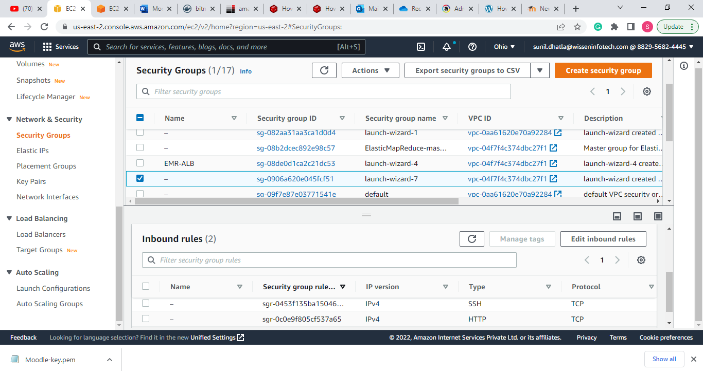

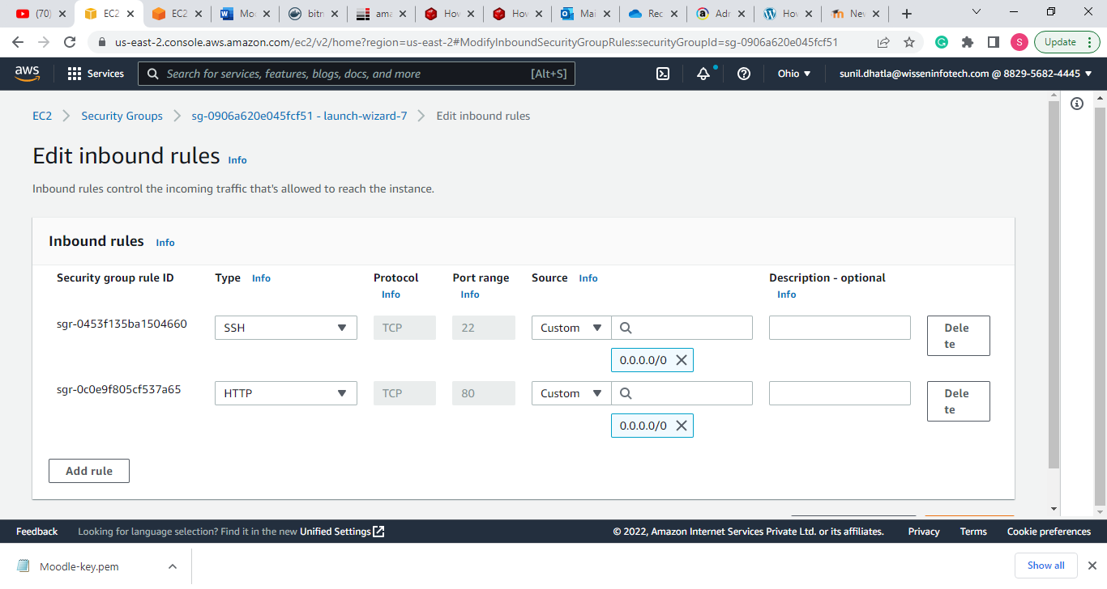

**Finally Moodle is Up and Running**

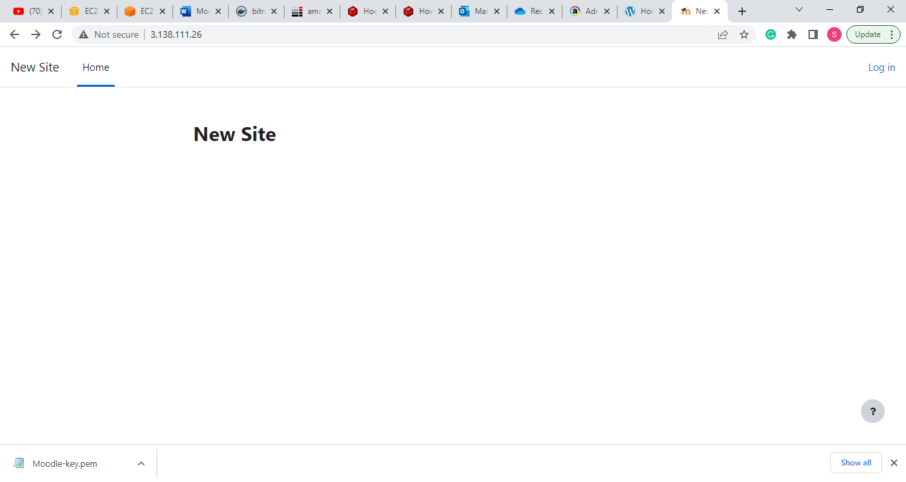

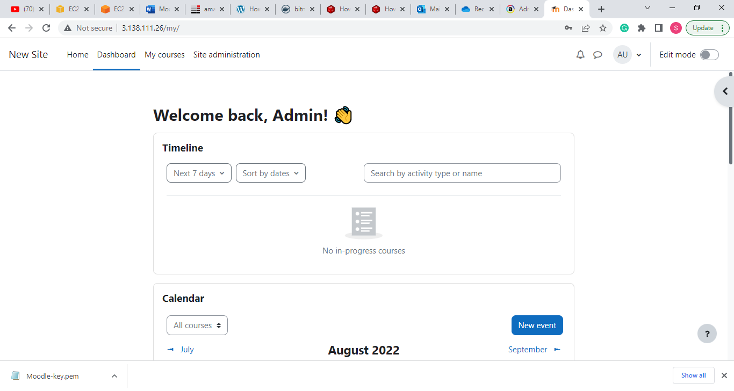

**Step 7:Use Elastic IP address for constant Moodle IP**

* Open Elastic IPs
* Click on Allocate Elastic IP address

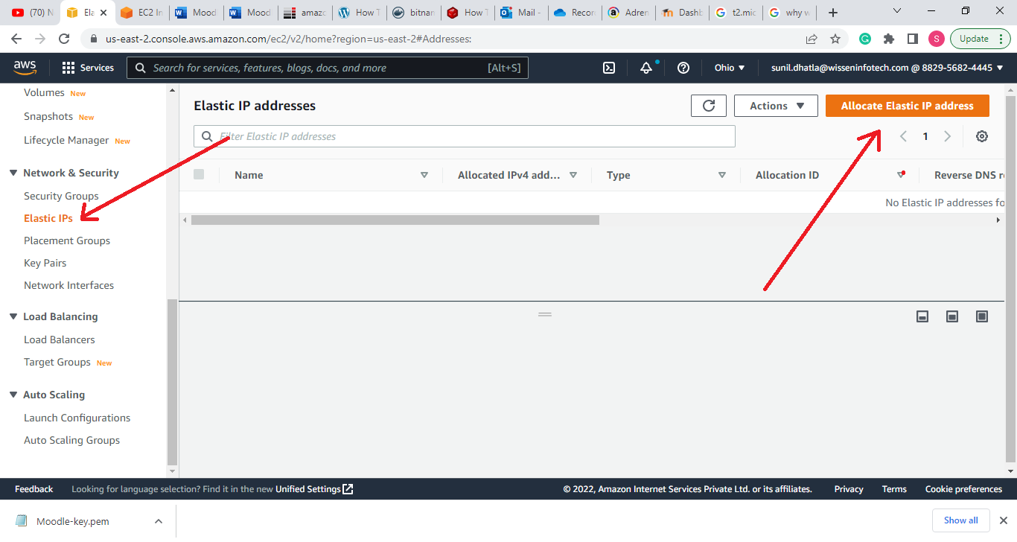

* Click on Allocated IP

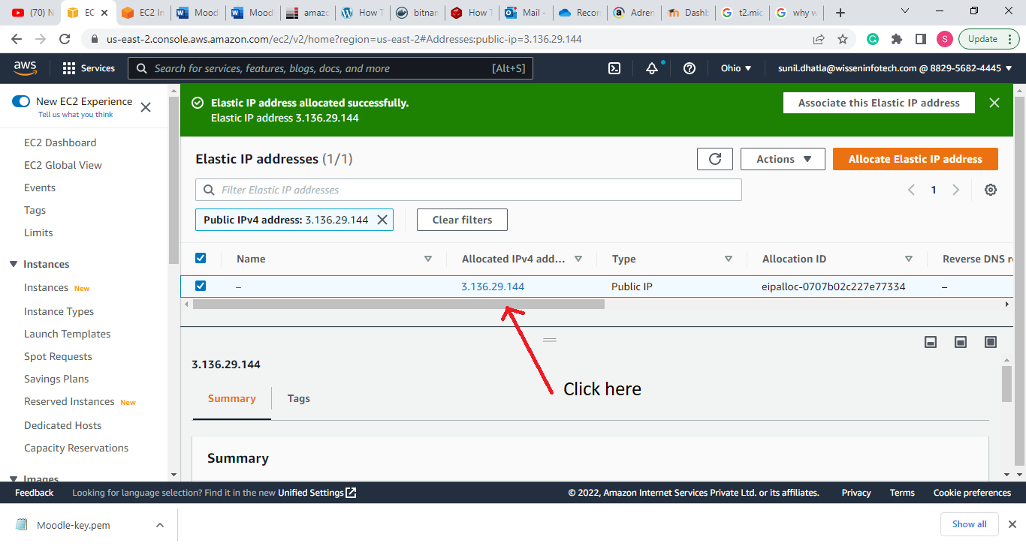

* Click on Associate Elastic IP

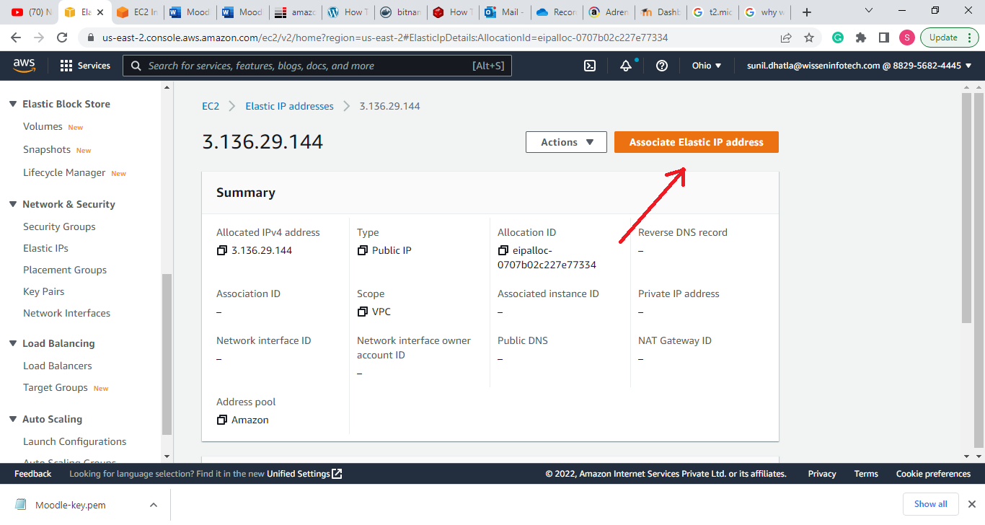

* Select your Instance
* Click on Associate (Elastic IP will get assign to selected Instance)

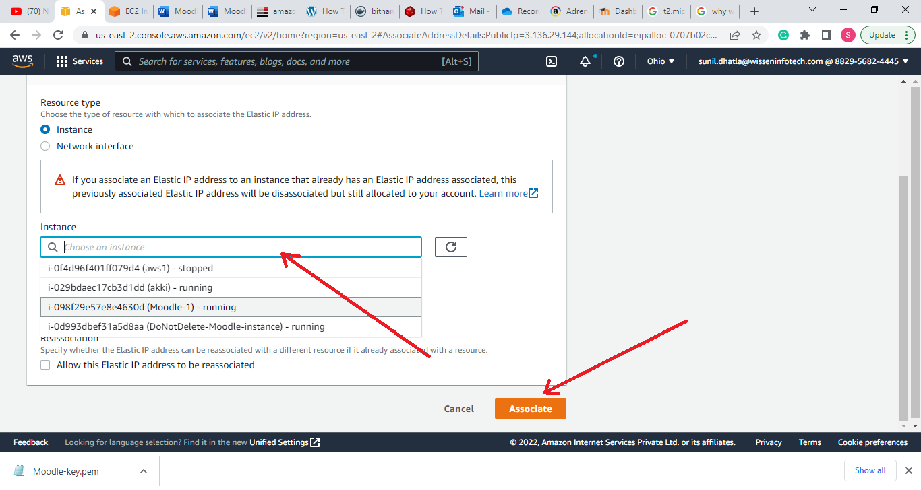

**Troubleshooting of Moodle down issue**

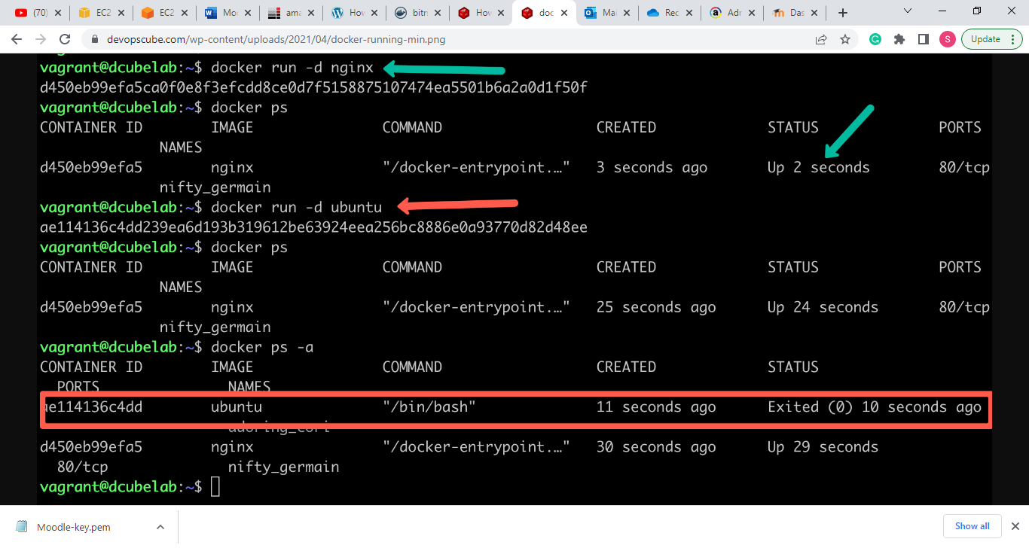

Step1: check weather docker is in active state

* systemctl status docker

Step2: Check the state of container image

* docker ps –a

Step3: If the container is down then make it in Up state

* docker start **0ab99d8ab11c**  ----> Container ID

**To make Container work continuously without getting down use these commands**

* docker run -d bitnami/moodle sleep infinity
* docker exec -it **0ab99d8ab11c** /bin/bash ----> Container ID
* docker-compose up -d

**Reference URL:**

1. **Installation of Docker**

<https://serverfault.com/questions/836198/how-to-install-docker-on-aws-ec2-instance-with-ami-ce-ee-update>

1. **Installation of Docker Compose**

<https://acloudxpert.com/how-to-install-docker-compose-on-amazon-linux-ami/>

1. **Installation of Bitnami/Moodle**

<https://hub.docker.com/r/bitnami/moodle>

1. **Dockerfile Command to Keep the Container Running**

<https://devopscube.com/keep-docker-container-running/#:~:text=Dockerfile%20Command%20to%20Keep%20the%20Container%20Running&text=Method%201%3A%20You%20can%20use,to%20keep%20the%20container%20running.&text=Method%202%3A%20You%20can%20run,via%20arguments%20as%20shown%20below.&text=Method%203%3A%20Another%20method%20is,a%20sleep%20command%20to%20infinity>.